Ninja Number Sliders – The Perfect Bedtime Maths Routine

This week your child will be bringing home a Ninja Number Slider. These sliders will support students in learning to partition (break apart) numbers, learning all the ways to make 3-10.

The aim is for children to learn the combinations that make a number. This involves learning to split numbers into smaller parts (decompose a number). Most students will start with 3 beads on their Ninja Number Slider. Once your child can visualise (see in their mind) and reliably remember all the combinations for 3 (“1 and 2 is 3; 2 and 1 is 3; 3 and 0 is 3; 0 and 3 is 3”) please bring the slider back to school, demonstrate to their teacher without using the slider for support, and then your child will be move up to the next Ninja Belt.

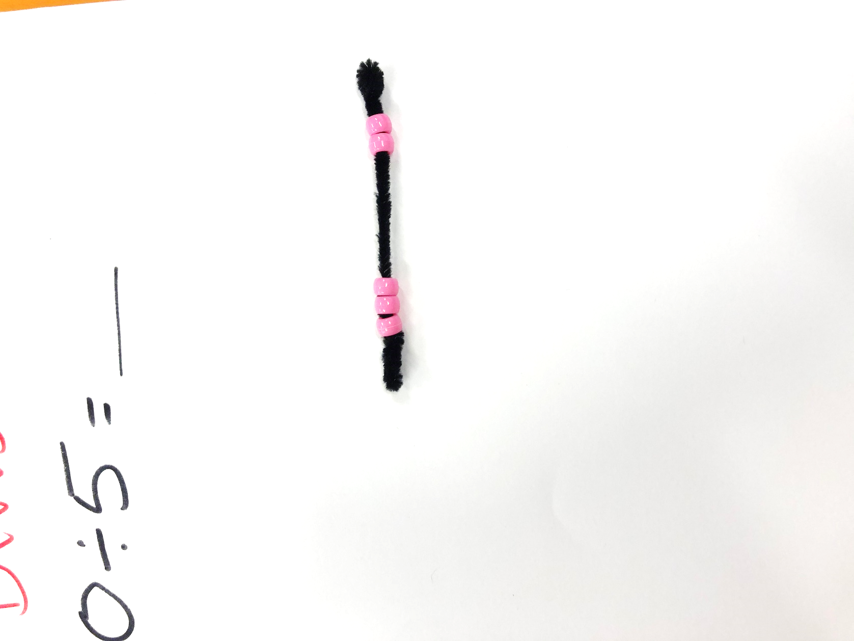
When using the Ninja Number Sliders, children can move the beads along the pipe cleaner so they can build and see all the different combinations. Students can also flip the slider over to see the commutative/turnaround property (2 and 1 is 3; flip around; 1 and 2 is 3).
We recommend including this as part of a 5-minute bedtime maths routine each day, alongside your child’s home reading routines.


“What are all the ways to make 5?”

“2 and 3 is 5”
“3 and 2 is 5”

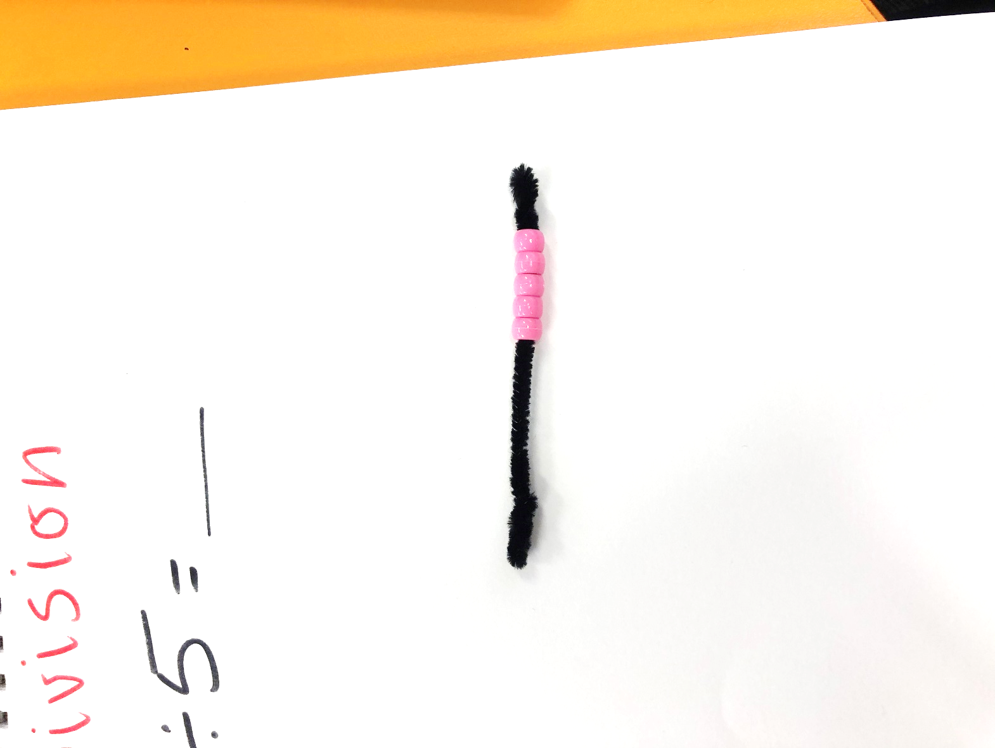
“4 and 1 is 5”
“1 and 4 is 5”

“5 and 0 is 5”
“0 and 5 is 5”

The Ninja Number sliders will be presented to the students as a Ninja Belt challenge where they move up the coloured belts.


